Kishan Sarpangala

M04307966

Assignment 3

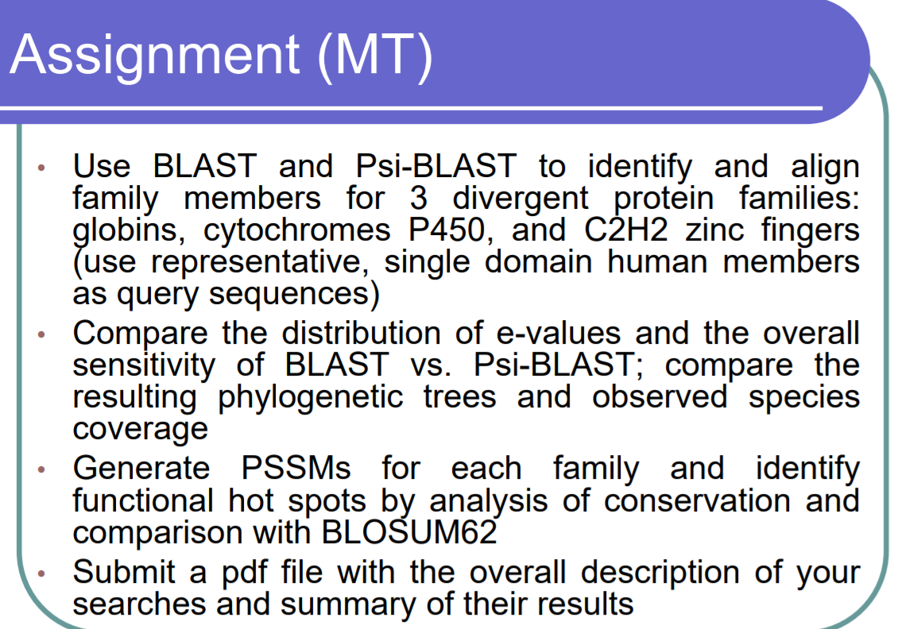

* Phylogenetic trees
* Species coverage?
* **Cytochrome P450**

**PSI-BLAST**

**First_iteration**:

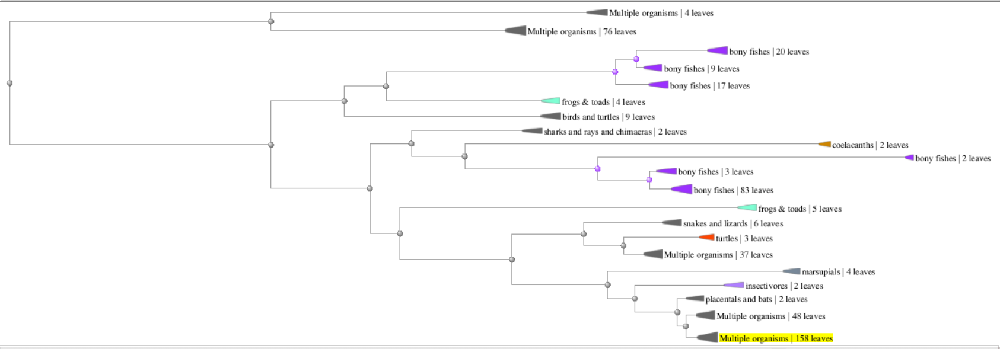

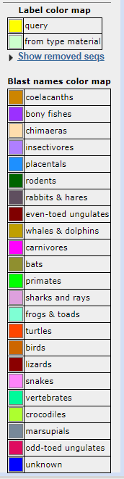 



**Second Iteration:**

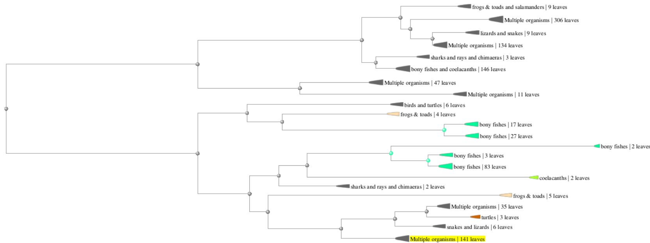



**Third Iteration**

